# **2010-2012 Sales Exploratory Analysis Report**

This report contains the exploratory data analysis of sales between 2010 and 2012 done using Python geared towards evaluating store performance and the impact of external factors such as fuel prices and markdown on sales.

## **Goals of the Analysis**

1. To identify daily sales patterns.
2. To compare sales across different stores.
3. To evaluate the effect of external factors on sales such as fuel price, markdown.
4. To identify the most profitable store and department.
5. To measure the correlation between fuel prices and sales.

## **KPIs to be Tracked**

1. Total sales.
2. Average sales per store
3. Best performing stores and departments.

## **Data Overview**

The data comprises of three merged datasets:

1. Sales dataset- contains weekly sales
2. Features-contains the external factors such as markdown, fuel prices, CPI.
3. Stores- contains the various stores and departments.

## **Key Insights**

1. Total sales

E:\Python Data Analysis\2010-2012 Sales Explatory Analysis\2010-2012-Exploratory -Sales-Analysis\code outcomes\total sales.PNG

Figure 1: Total Sales

1. Average sales per store

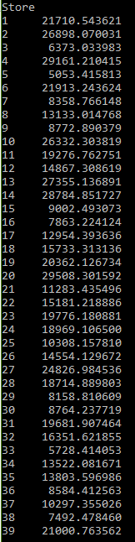

Figure 2:Average Sales per Store

1. Datatypes present

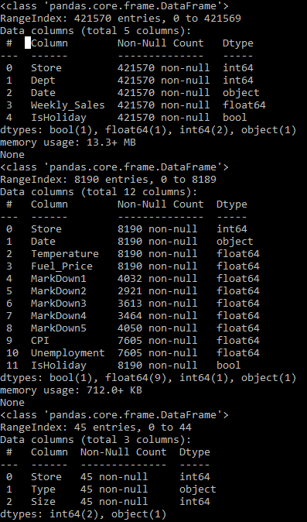

Figure 3:Datatypes Present

1. Sales during markdown

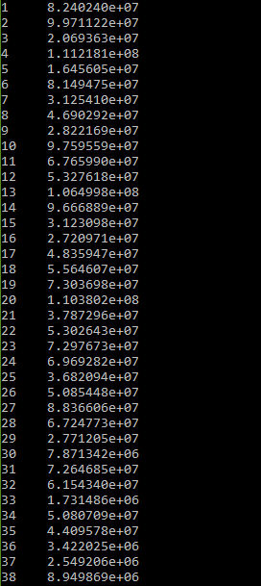

Figure 4:Sales During Markdown

1. Top performing stores

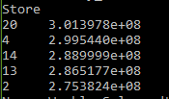

Figure 5:Top Performing Stores

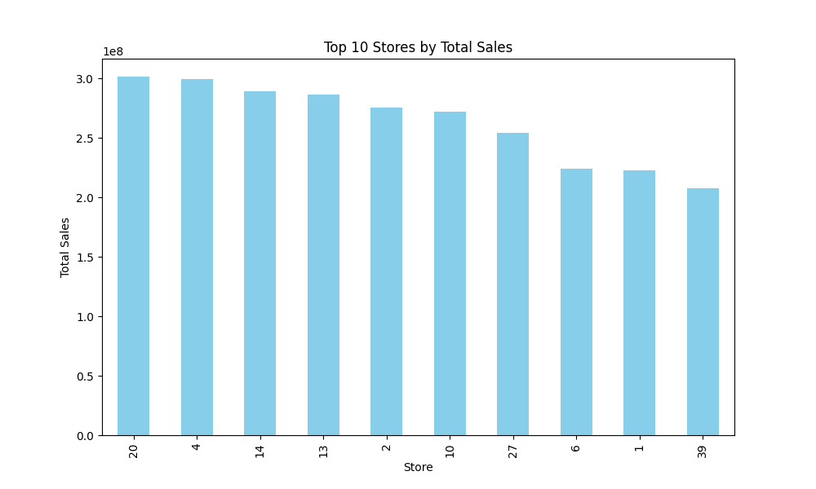

Figure 6:Top Performing Stores Plot

1. Correlation between fuel prices and weekly sales.

E:\Python Data Analysis\2010-2012 Sales Explatory Analysis\2010-2012-Exploratory -Sales-Analysis\Plots and Visualizations\correlation of fuel prices and sales.PNG

Figure 7: Correlation between Fuel Prices and Sales

## **Sales Analysis**

Weekly sales were analyzed based on time. Gradual increase was observed indicative of growth.

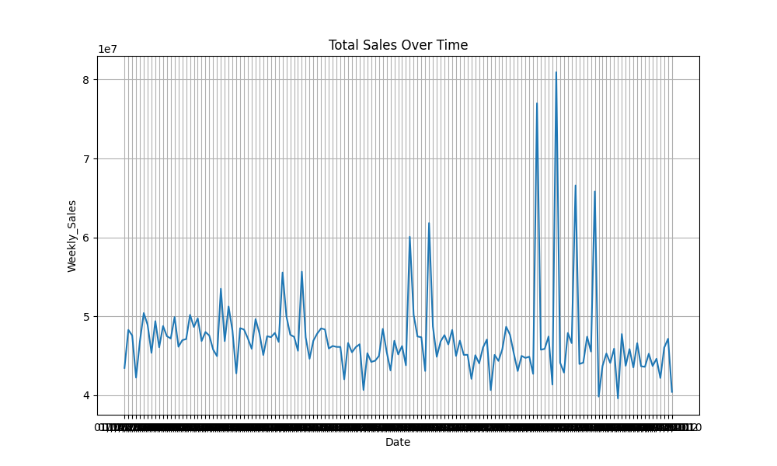

Figure 8:Plot of Sales based on Time

## **Impact of External Factors**

The relationships between sales and external factors like markdowns and fuel prices were analyzed.

Findings include:

1. **Markdowns:** Increased markdowns were associated with higher sales during specific weeks.

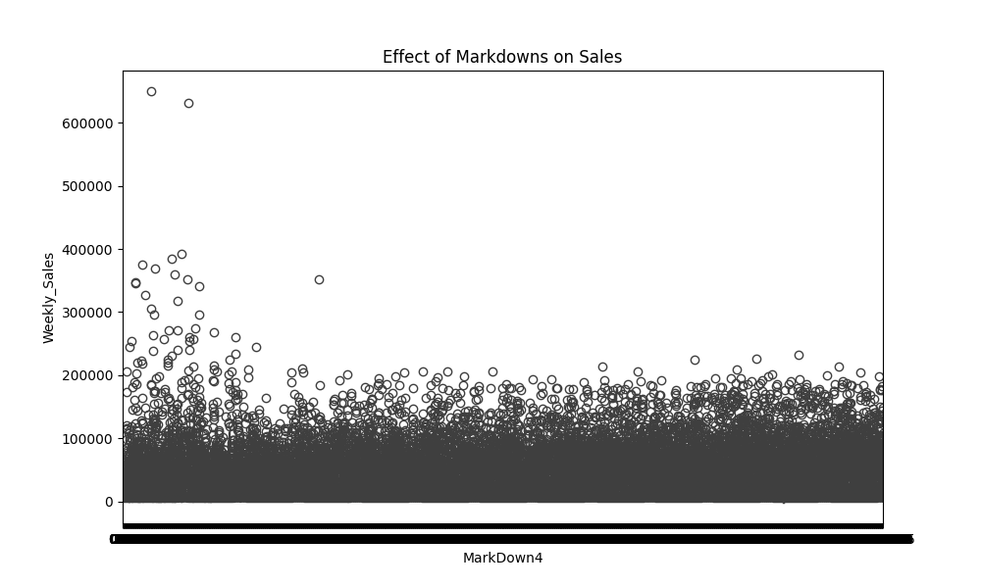

Figure 9: Effect of Markdown on Sales

1. **CPI**: No significant correlation between CPI and sales.
2. **Fuel Prices**: Higher fuel prices resulted in lower sales.

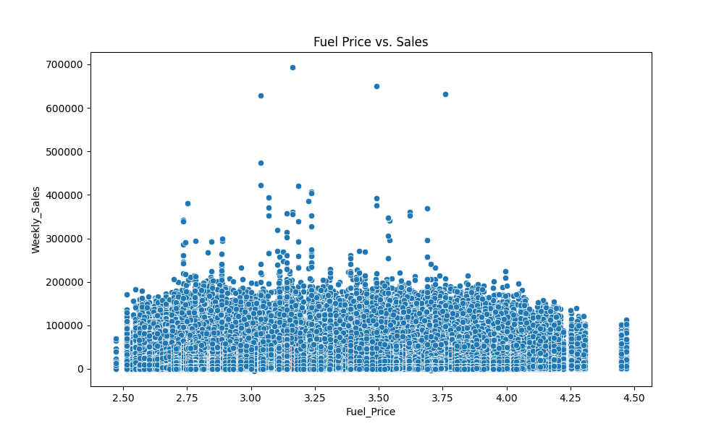

Figure 10:Fuel Prices vs Sales

## **Recommendations**

Based on the analysis, the following actions are recommended to improve sales performance:

1. **Maximize markdowns during peak seasons**-Promotions can boost sales.
2. **Focus on high-performing stores and departments**- Increase inventory and marketing for store 20.
3. **Monitor external factors**- Keep track of fuel prices and adjust logistics or pricing strategies accordingly.